<MySvm>

1. C=1.00

1. gen_lin_separable Data

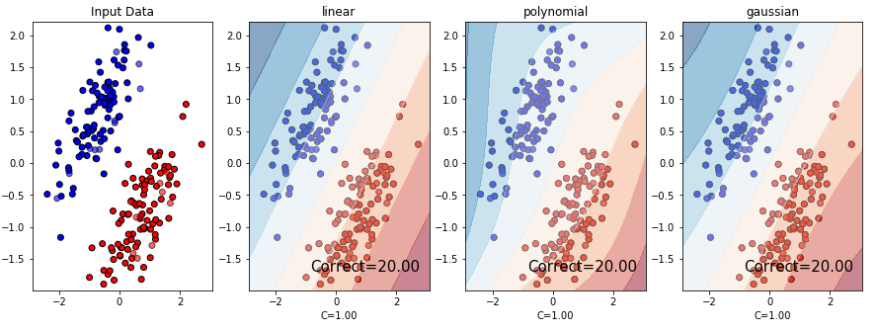

1. gen_non_lin_separable Data

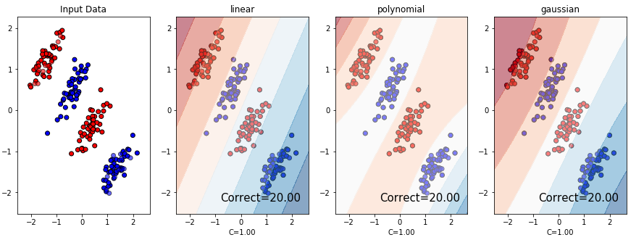

1. gen_lin_separable_overlap_data

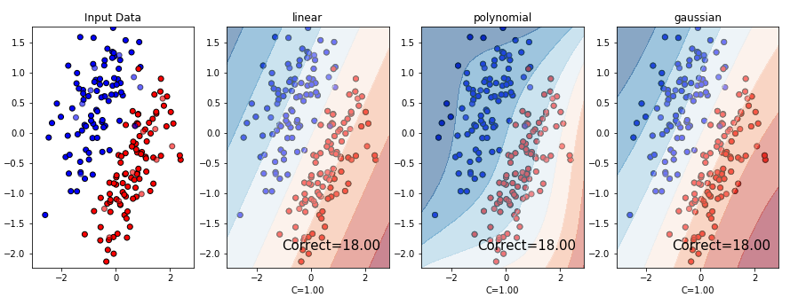

2. C=10.00

1. gen_lin_separable Data

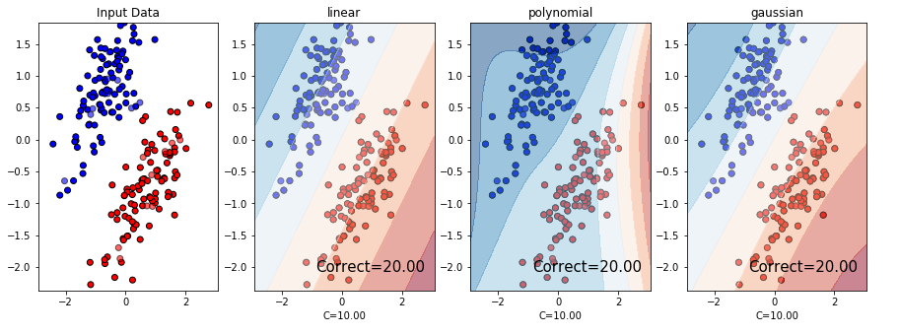

1. gen_non_lin_separable Data

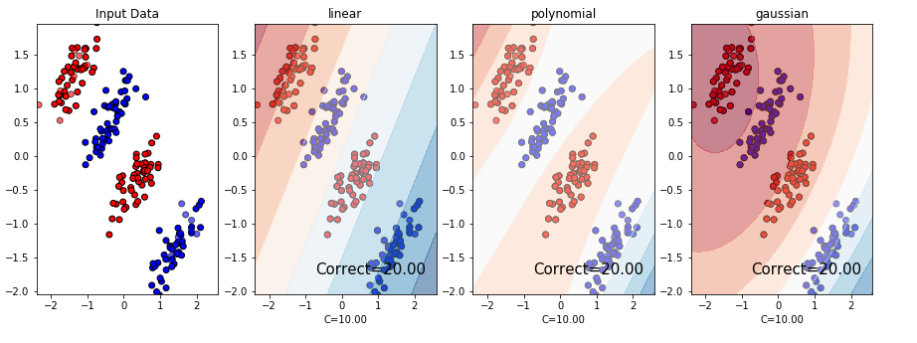

1. gen_lin_separable_overlap_data

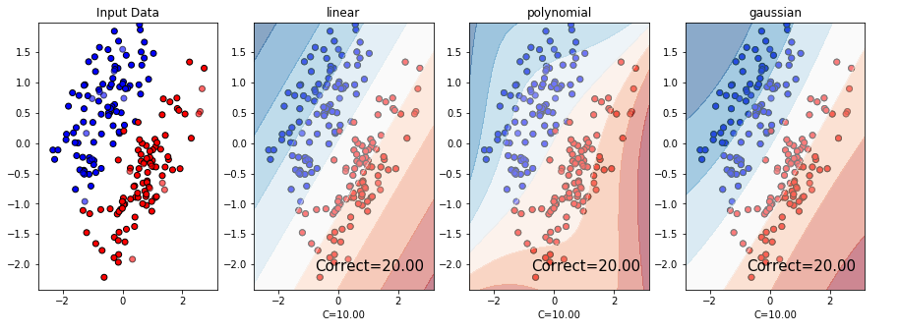

3. C=100.00

1. gen_lin_separable Data

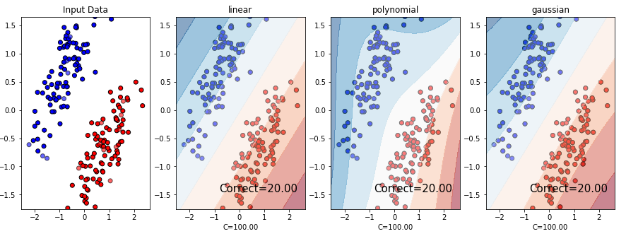

1. gen_non_lin_separable Data(sigma=2.0)

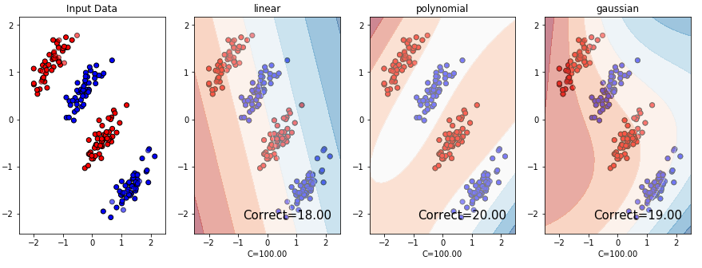

B-1. gen_non_lin_separable Data(sigma=5.0)

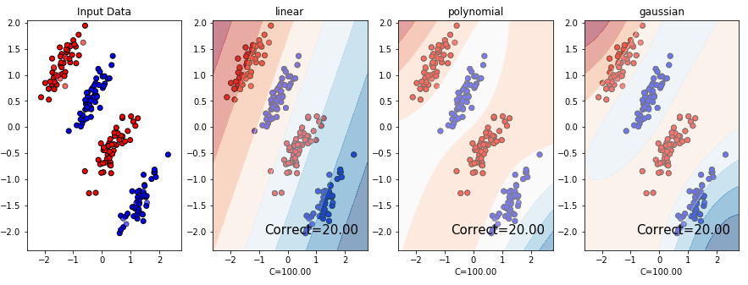

1. gen_lin_separable_overlap_data

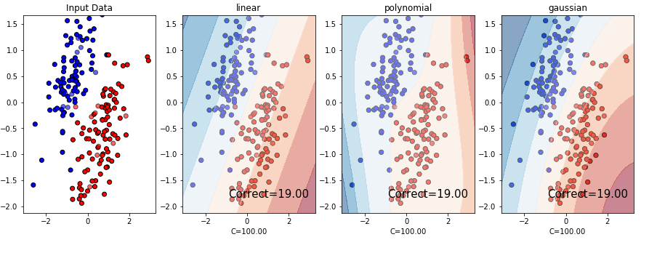

C-1. gen_lin_separable_overlap_data(sigma=2.0)

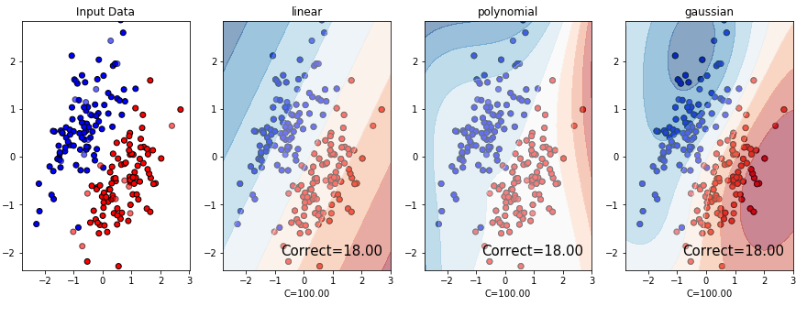

<SVM package>

-gen_non_lin_separable Data

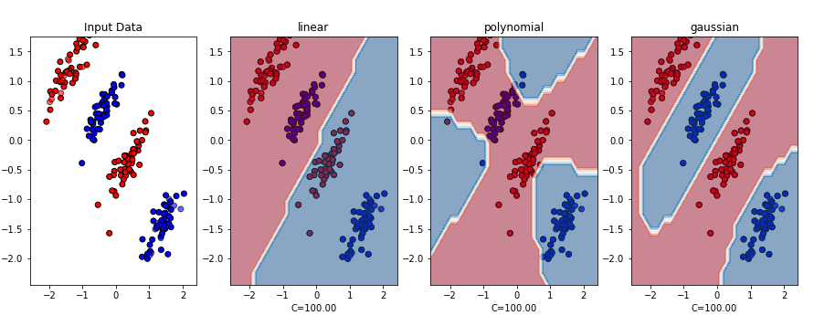

<My SVM>

